Today’s Date: _____________________

Patient’s Name: _____________________________________Date of Birth: _______________________
Address: _____________________________________________________________________________
City: _______________________________ State: ___________________ Zip: _____________________
Home Phone: _________________________________ Work Phone: _____________________________
Occupation: ________________________________________ How Long: _________________________
Doctor: ____________________________________________ Phone: ____________________________
Address: _____________________________________________________________________________
City: _______________________________ State: ___________________ Zip: _____________________
Attorney: __________________________________________ Phone: ____________________________
Address: _____________________________________________________________________________
City: _______________________________ State: ___________________ Zip: _____________________
Employer: _________________________________________ Phone: ____________________________
Address: _____________________________________________________________________________
City: _______________________________ State: ___________________ Zip: _____________________
Emergency Contact: ________________________________________ Phone: _____________________

Is this case related to: Work ____ Auto ____ Other __________________________________

If it happened at work, has the employer been notified? Yes ____ No ____
Has the Insurance company been notified? Yes ____ No ____
Are you presently employed? Yes ____ No ____
If work related, are you still working for the same employer? Yes ____ No ____
Were you taken/admitted to the hospital? Yes ____ No ____
If this was an auto accident, is there a police report on file? Yes ____ No ____
Were you taken / admitted to the hospital? Yes ____ No ____

Please check any of the following that apply to you—in the past mark (P) or currently mark (X):

___ Heart Problems ___ Arthritis ___ Spinal Problems
___ High Blood Pressure ___ Osteoarthritis ___ Disc Problems
___ Heart Attack ___ Stroke ___ Knee/Shoulder Injuries
___ Blood Clots ___ Back Problems ___ Accidents or Injuries
___ Varicose Veins ___ Pregnant ___ Major Illiness/Disease
___ Pacemaker ___ Diabetes ___ Breaks/Sprains
___ Neurological Problems ___ Surgery ___ Cancer
___ Headaches ___ Epilepsy or Seizures ___ Skin Conditions
___ Allergies ___ Bruise easily ___ Sleeping Conditions
___ Whiplash ___ Chemical Dependency ___ Constipation/Diarrhea
___ Auto-Immune Disorders ___ Depression, Panic Disorder
(AIDS, Fibromyalgia, Chronic or Other Physiological Issues
Fatigue, Lupus, etc.)

Briefly explain what happened: ___________________________________________________________
_____________________________________________________________________________________

Use the following codes to mark your pain:
S = Sharp D = Dull ache N = Numb
SH = Shooting B = Burning T = Tingling

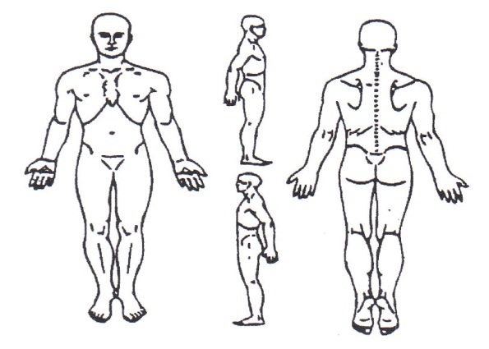
Do you have any pre-existing conditions that relate to this present injury? Yes ____ No ____
If yes, please explain: ___________________________________________________________________

Release Form
I have read and filled out all information as truthfully as I know it to be. I also understand that with this type of treatment, it can and will leave marks that look like bruises due to capillary breakage which is a part of the healing process. Also, this treatment can and will cause an inflammatory process to occur so I might feel worse before I get better. I have also been made aware of the post treatment care and will follow that to help in my recovery. At no time, will myself nor any other party hold Advanced Muscular Therapy, it’s owner or therapist’s responsible for any injuries that may occur or if the condition worsens.

The Client/Patient assumes full responsibility for their injuries. They or any member of their family fully releases Advanced Muscular Therapy, it’s owner or any of it’s therapists from any and all claims, demands, damages, rights of action, or cause of action, present or future and accept full responsibility for any injury that may occur by receiving treatment at this facility. Whether the same is known or unknown, anticipated, resulting from or arising out of the client/patient use or intended use of the facility and equipment thereof.

By the execution of this agreement, the Client/Patient assumes full responsibility for any such injuries or damages which may occur to the Client/Patient in or about the premises. The Client/Patient expressively agrees that Advanced Muscular Therapy, it’s owner, any of it’s therapists and the landlord of the property shall not be liable for any damages arising from personal injuries sustained by the Client/Patient in or about the premises. The Client/Patient does hereby fully and forever release and discharge Advanced Muscular Therapy, it’s owner or any of it’s therapist from any and all claims, demands, damages, rights of action or cause of action present or future.

The Client/Patient agrees that he/she has read and fully understands this release form.

Client/Patient Signature: ______________________________________________ Date:____________________
(Patient is responsible for payment not covered by insurance)
INSURANCE INFORMATION
Patient’s Full Name: __________________________________________________________________
Address: _____________________________________________________________________________
City: ________________________________ State: ____________________ Zip: ___________________
Home phone: ___________________________________ Work: ________________________________
Date of Birth: _______________________________ Social Security: _____________________________
Employer __________________________________ Job Title: __________________________________
Address: _____________________________________________________________________________
City: _______________________________ State: _____________________ Zip: ___________________
Date of Accident: ____________________________ Type of Injury: _____________________________

Insured’s Name: ______________________________________________________________________
(For Workers Comp Cases; Name of Business)
Address: _____________________________________________________________________________
City: ________________________________ State: ____________________ Zip: __________________
Date of Birth: ______________________________ Social Security: ______________________________
Home phone: __________________________________ Work: _________________________________
Present Employer: ___________________________ Job Title: __________________________________
Employers Address: ____________________________________________________________________
City: _______________________________ State: _____________________ Zip: ___________________
Patient’s Relationship to Insured (Spouse, Child, Other): _______________________________________

Insurance Company: __________________________________________________________________
Claims Office Address: __________________________________________________________________
City: _______________________________ State: _____________________ Zip: ___________________
Phone: ___________________________________ Fax: ________________________________________
Adjuster: _________________________________ Policy #: ____________________________________
Claim #: __________________________________ Group #: ____________________________________

Co-Insurance: ________________________________________________________________________
Address: _____________________________________________________________________________
City: _______________________________ State: ____________________ Zip: ____________________
Phone: __________________________________ Fax: _________________________________________
Adjuster: ________________________________ Policy #: _____________________________________
Claim #: _________________________________ Group #: _____________________________________

Client/Patient Signature: __________________________________________ Date: ________________
(Patient is responsible for payment not covered by insurance)

